HOME PAGE



Upcoming Events – Scholarship - Registration



Travel changes to Latest Posts

Newest Members changes to ET-RT Members


BLOG POST
http://besocial.wp4life.com/4-must-have-devices-for-any-apple-fanboy/
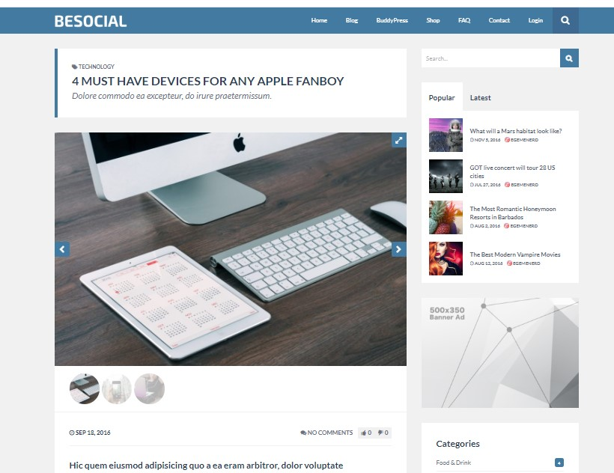
ET-RT Members Page
https://aardvark.ghostpool.com/original/members/
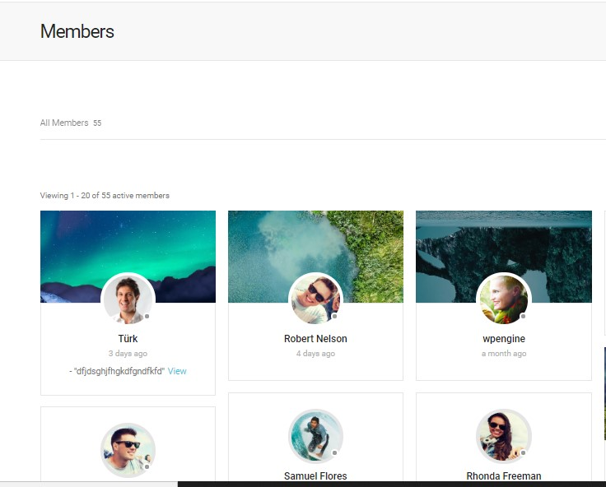
ContactUs Page
